**EXP NO: 01**

**DATE: 13-04-24**

**Aim:**

Create a simple cloud software application for Flight Reservation System using any Cloud Service Provider to demonstrate SaaS include the necessary fields such as one way, round trip, From, to, Departure, Departure, Travelers & Class, Fare Type, International and Domestic Flights etc.

**Implementation:**

**1. Go to Zoho.com and login/signup**

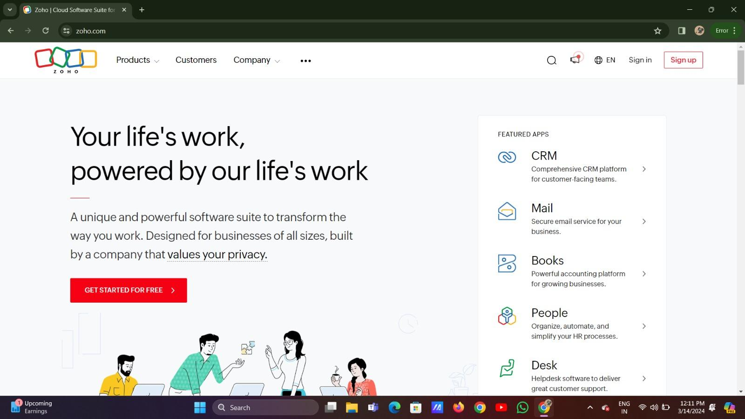

**2. Go to Creator**

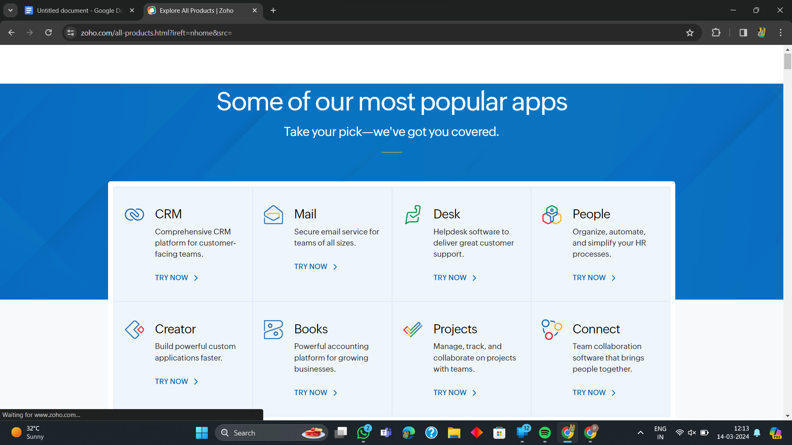

**192211093 PAGE1**

**3. Create A New Application**

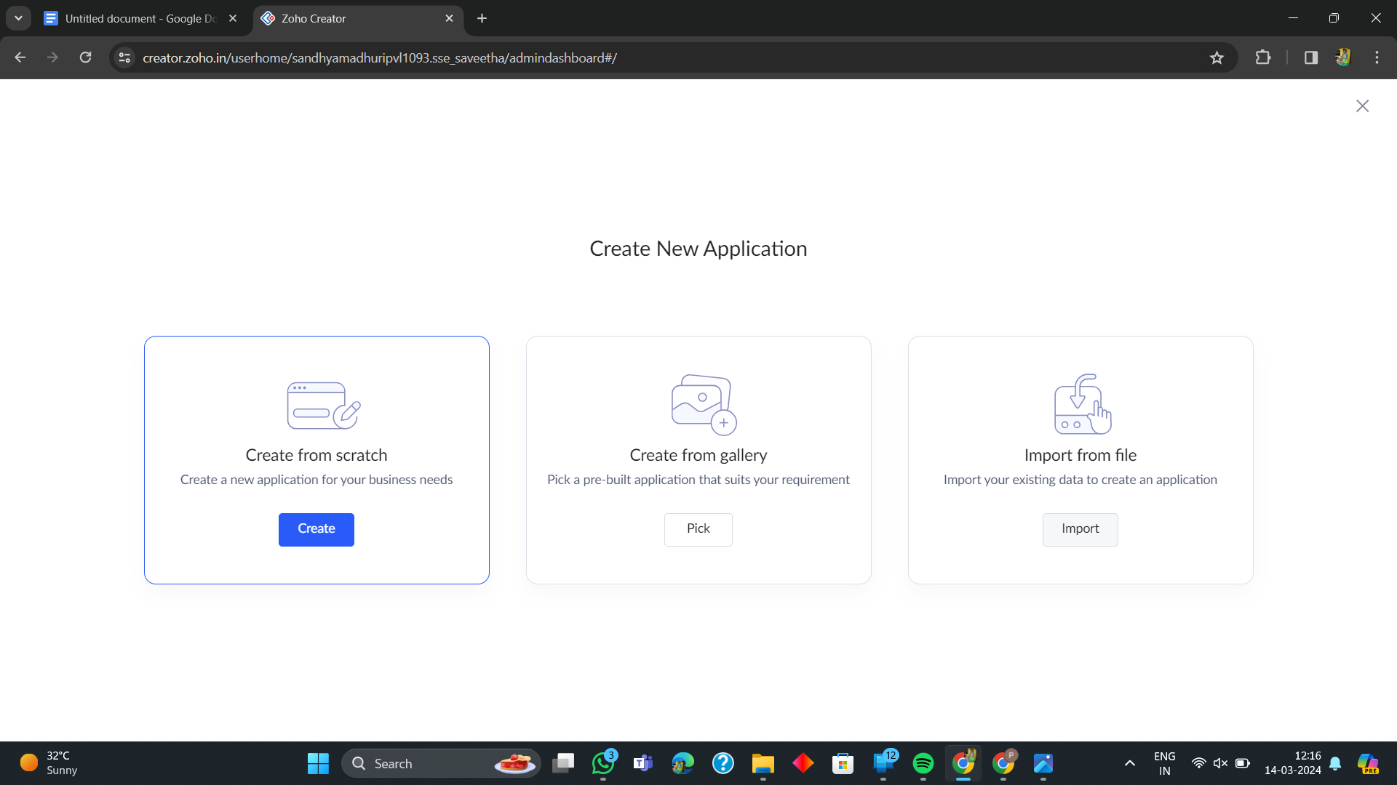

**4. Given Application Name**

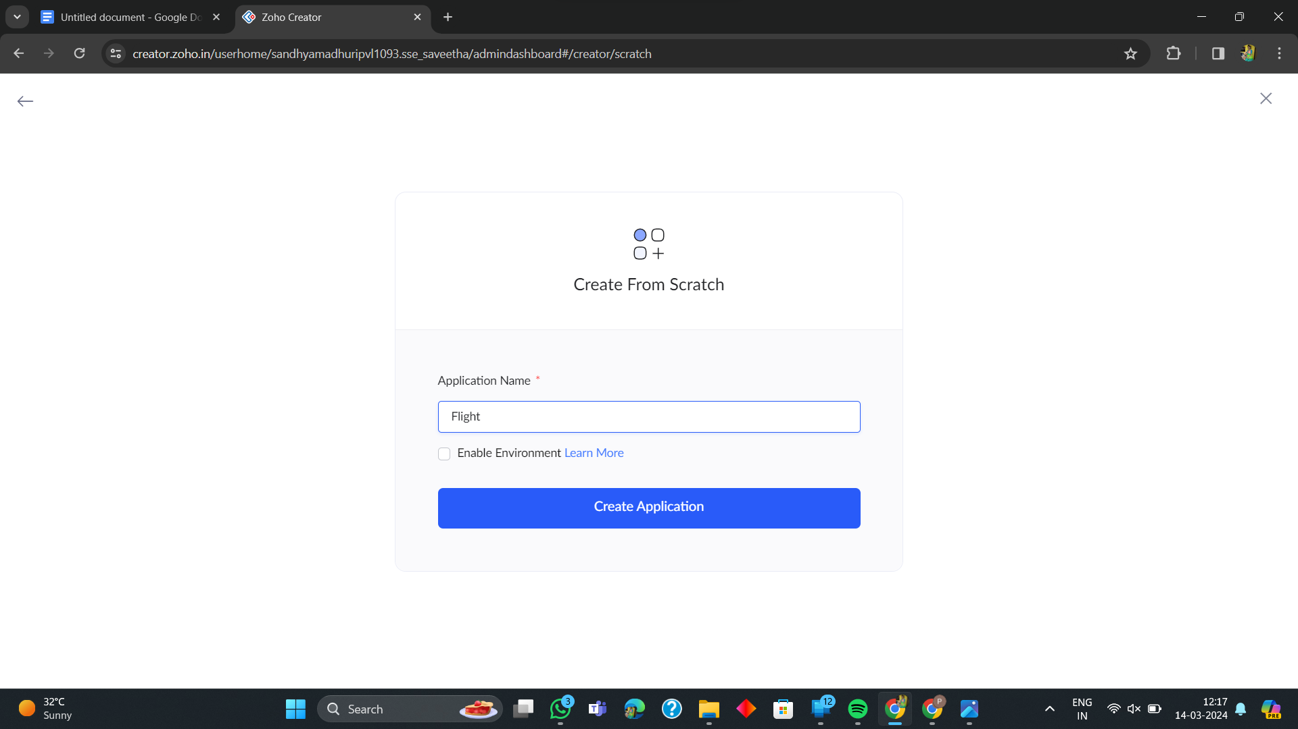

**5. Create New Form**

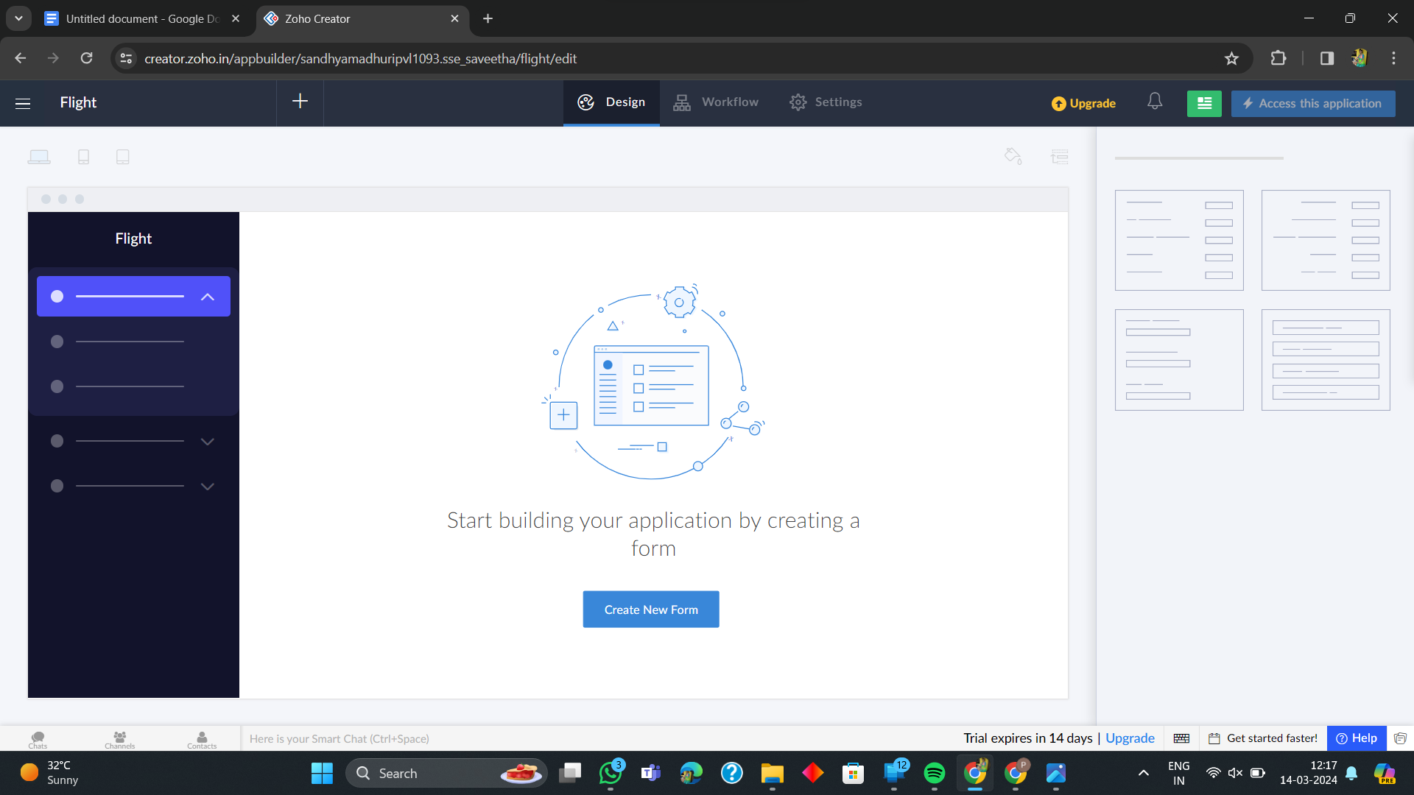

**192211093 PAGE2**

**6. Select Form and Give Name**

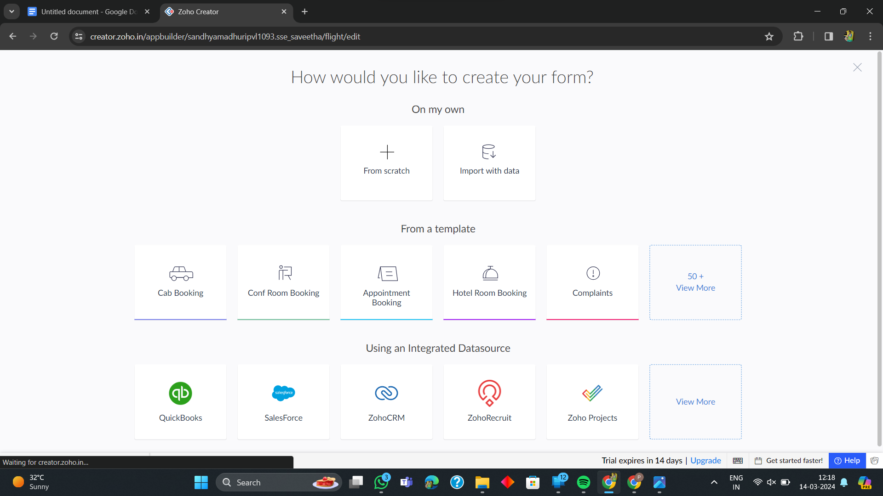

**7. Drag necessary fields**

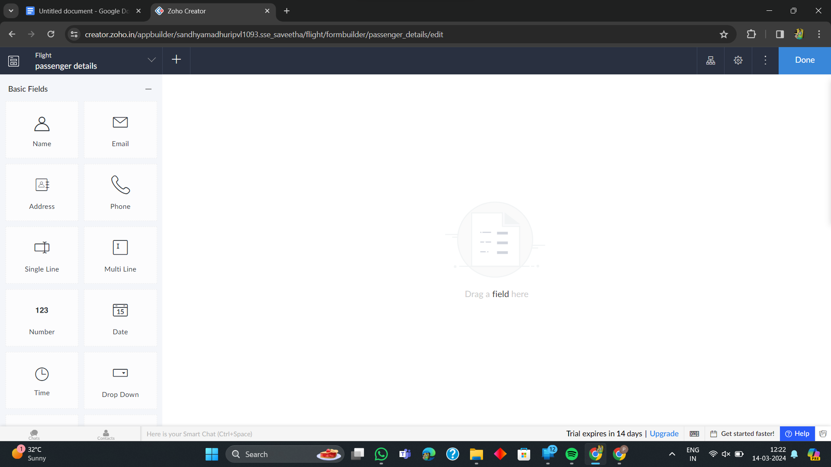

**192211093 PAGE3**

**8. The Software Has been created**

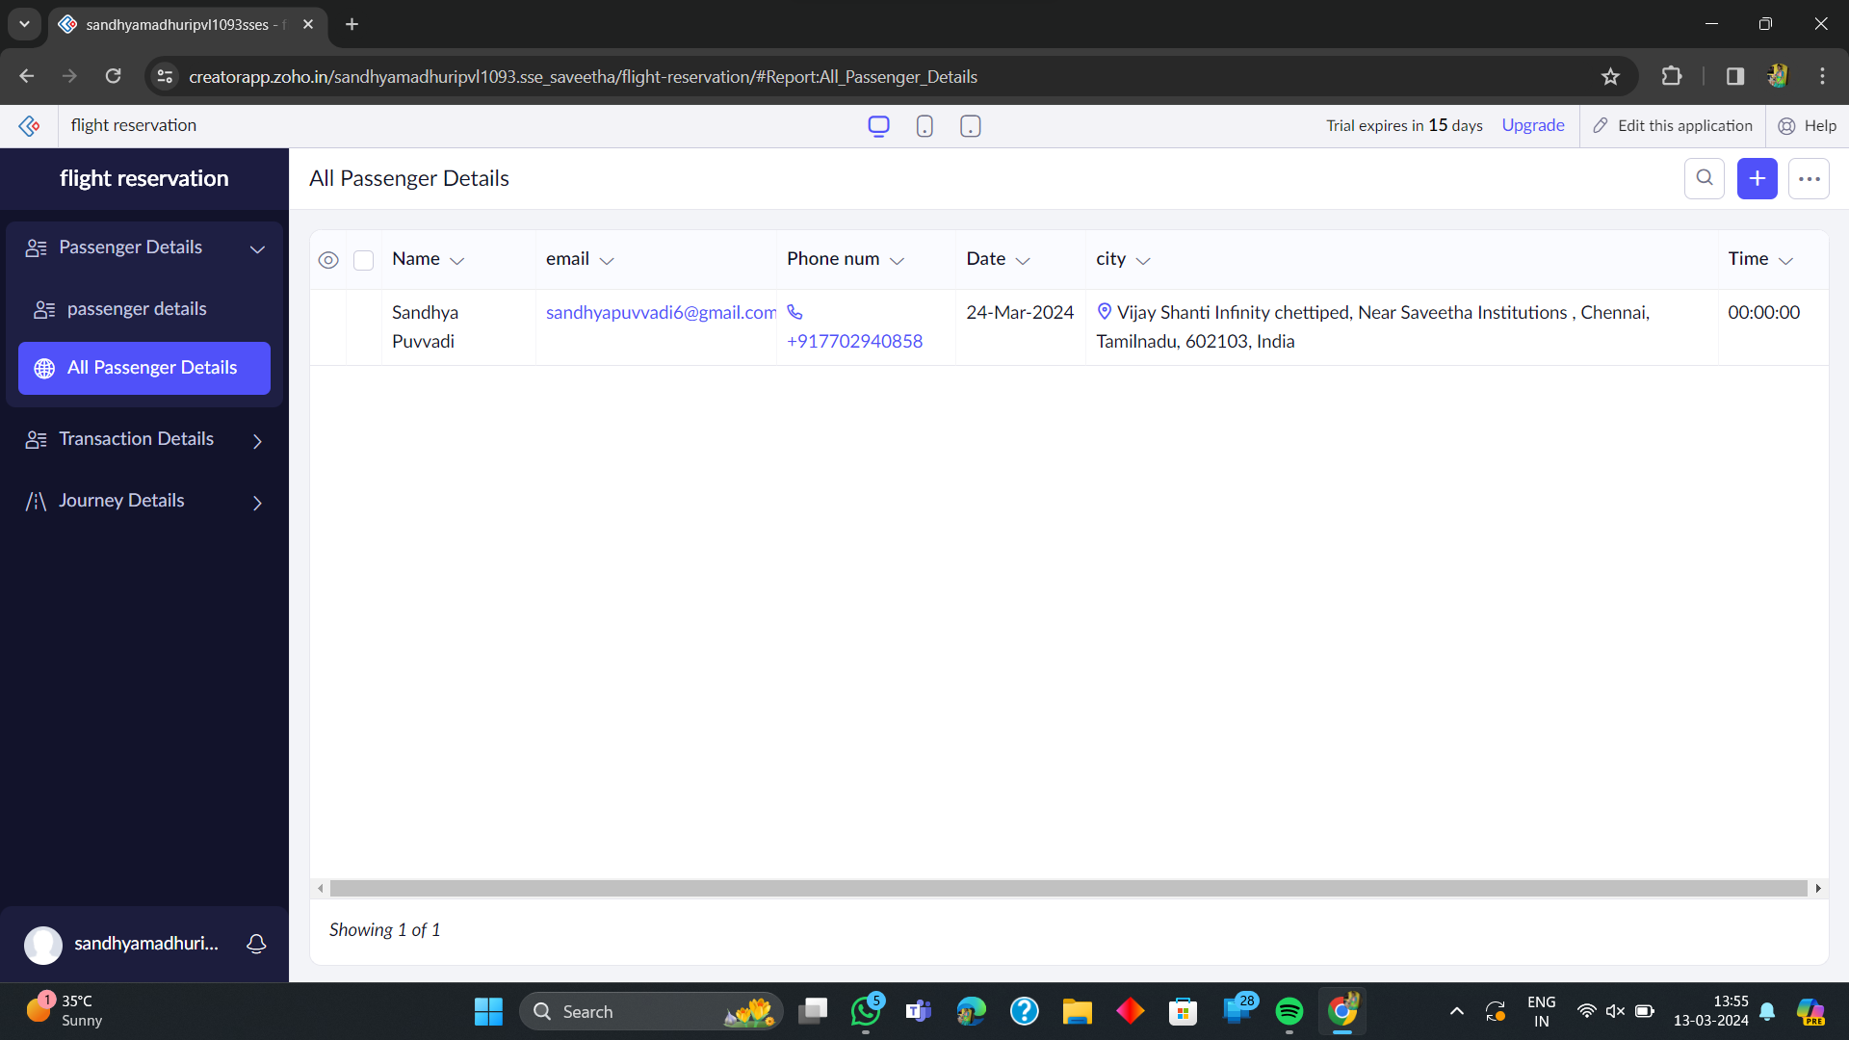

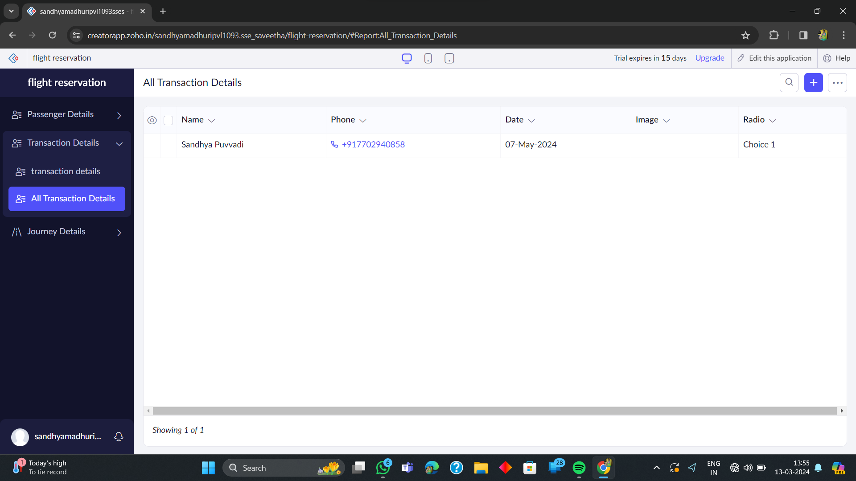

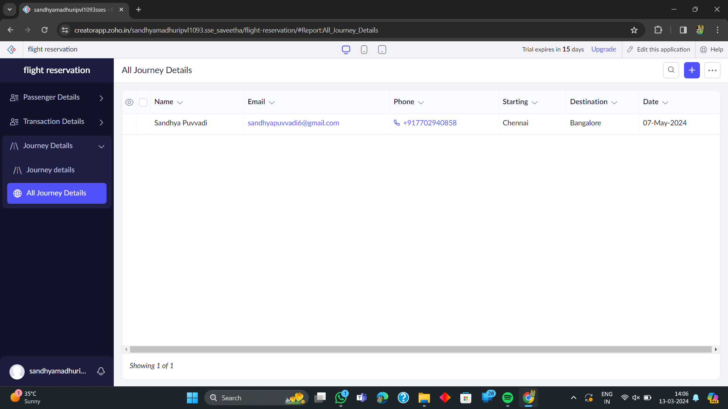

**192211093 PAGE4**